|  |  |
| --- | --- |
| Test No | Plan |
| 1 | Test the constructor |
| 2 | Test the set methods |
| 3 | Test the get methods |
| 4 | Test the toString method |
| 5 | Test the format method |

|  |  |
| --- | --- |
| Test No | Purpose |
| 1 | To test that the constructor is passing through the correct methods, and is operating accordingly |
| 2 | To test the set methods are setting new variables |
| 3 | To test the get methods are retrieving the right data/inputs |
| 4 | To test whether the test layout is working |
| 5 | To test whether the neat format layout is working |

**Screen shot of the full test:**   
  
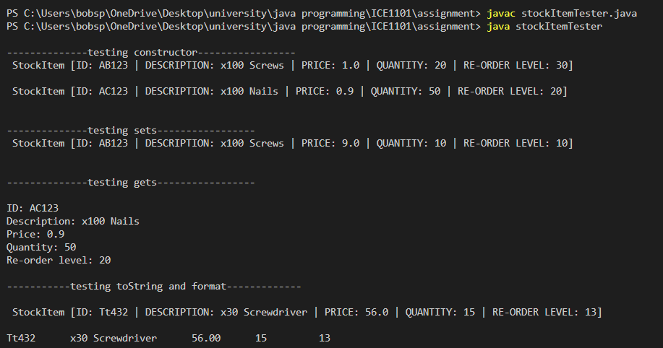

|  |  |  |  |  |
| --- | --- | --- | --- | --- |
| Test No | Input | Expected result | Actual result | Performance |
| 1 | item1 | “AB123”, “x100 screws” 1.00, 20, 30 | StockItem[ID: AB123 | DESCRIPTION: x100 Screws | PRICE: 1.0 | QUANTITY: 20 | RE-ORDER LEVEL: 30] | Check |
| 2 | 9.00, 10, 10 | “AB123”, “x100 screws” 9.00, 10, 10 | StockItem[ID: AB123 | DESCRIPTION: x100 Screws | PRICE: 9.0 | QUANTITY: 10 | RE-ORDER LEVEL: 10] | Check |
| 3 | item2 | “Ac123”, “x100 Nails”, 0.90, 50, 20 | ID: AC123  Description: x100 Nails  Price: 0.9  Quantity: 50  Re-order level: 20 | Check |
| 4 | item3 | StockItem [ID: Tt432 | DESCRIPTION: x30 Screwdriver | PRICE: 56.0 | QUANTITY: 15 | RE-ORDER LEVEL: 13] | StockItem [ID: Tt432 | DESCRIPTION: x30 Screwdriver | PRICE: 56.0 | QUANTITY: 15 | RE-ORDER LEVEL: 13] | check |
| 5 | item3 | Tt432 x30 Screwdriver 56.0 15 13 | Tt432 x30 Screwdriver 56.0 15 13 | Check |

**Fail action:** If a test fails then the method failure will be recorded, and a fix will be implemented.